OJT Updation via Back-Up

1) PMS Login →Organization Tree → HR → HR → HR

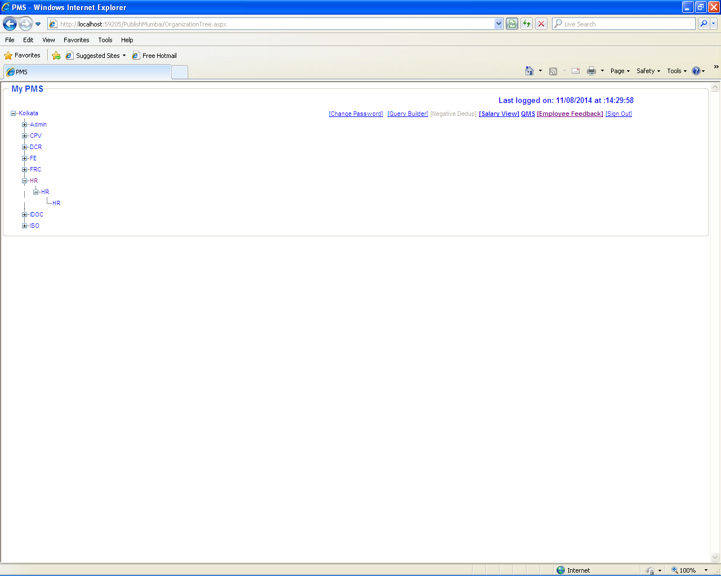
2) Performance Appreciation Tracker → Daily Productivity Tracker.

Select “Daily Productivity Tracker” option to “Add/Update OJT” record.

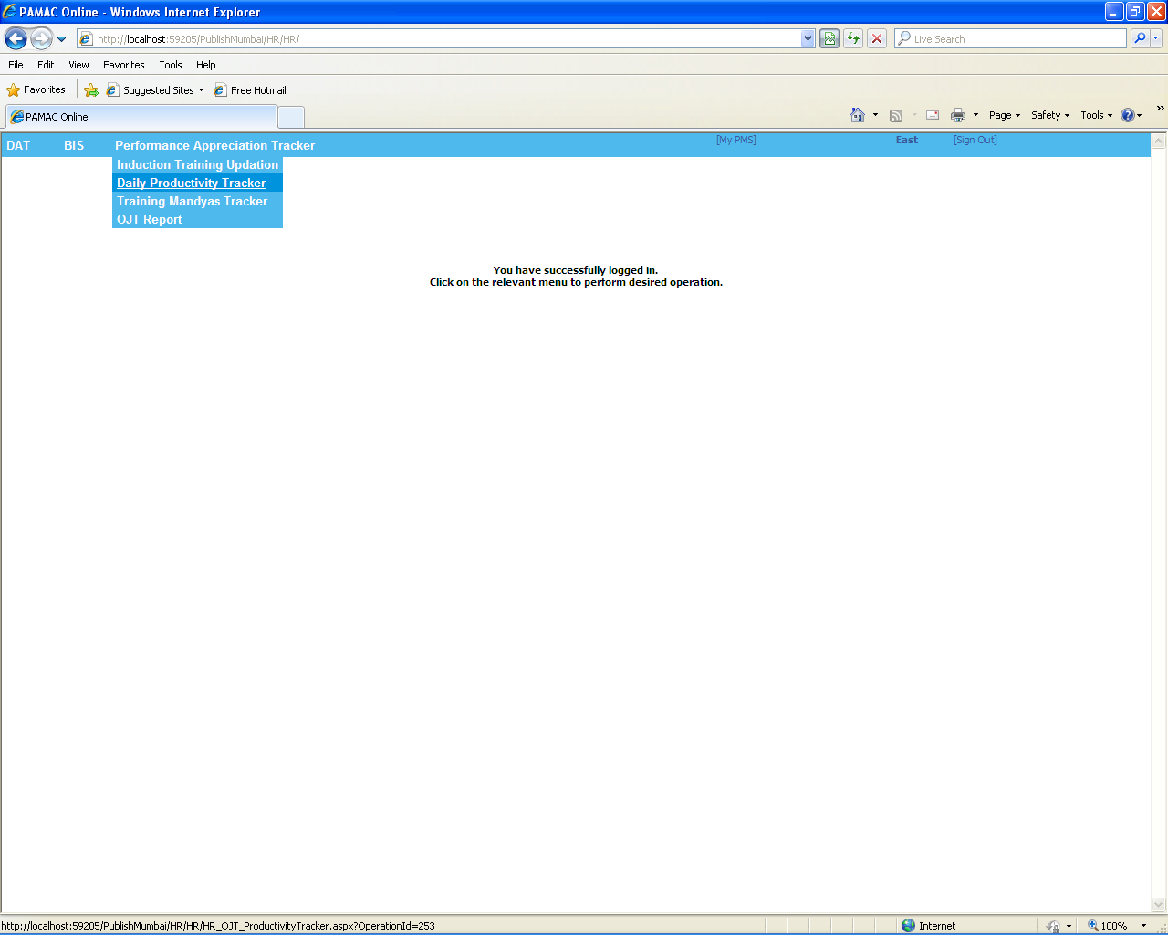
3) Click on “Search” button to update OJT records by,
- Selecting Cluster Name.
- Selecting Centre Name.
- Selecting Sub centre Name.
- Between Date range (From Date & To Date).
- Entering PAMACian Code.
- Entering PAMACian Name.

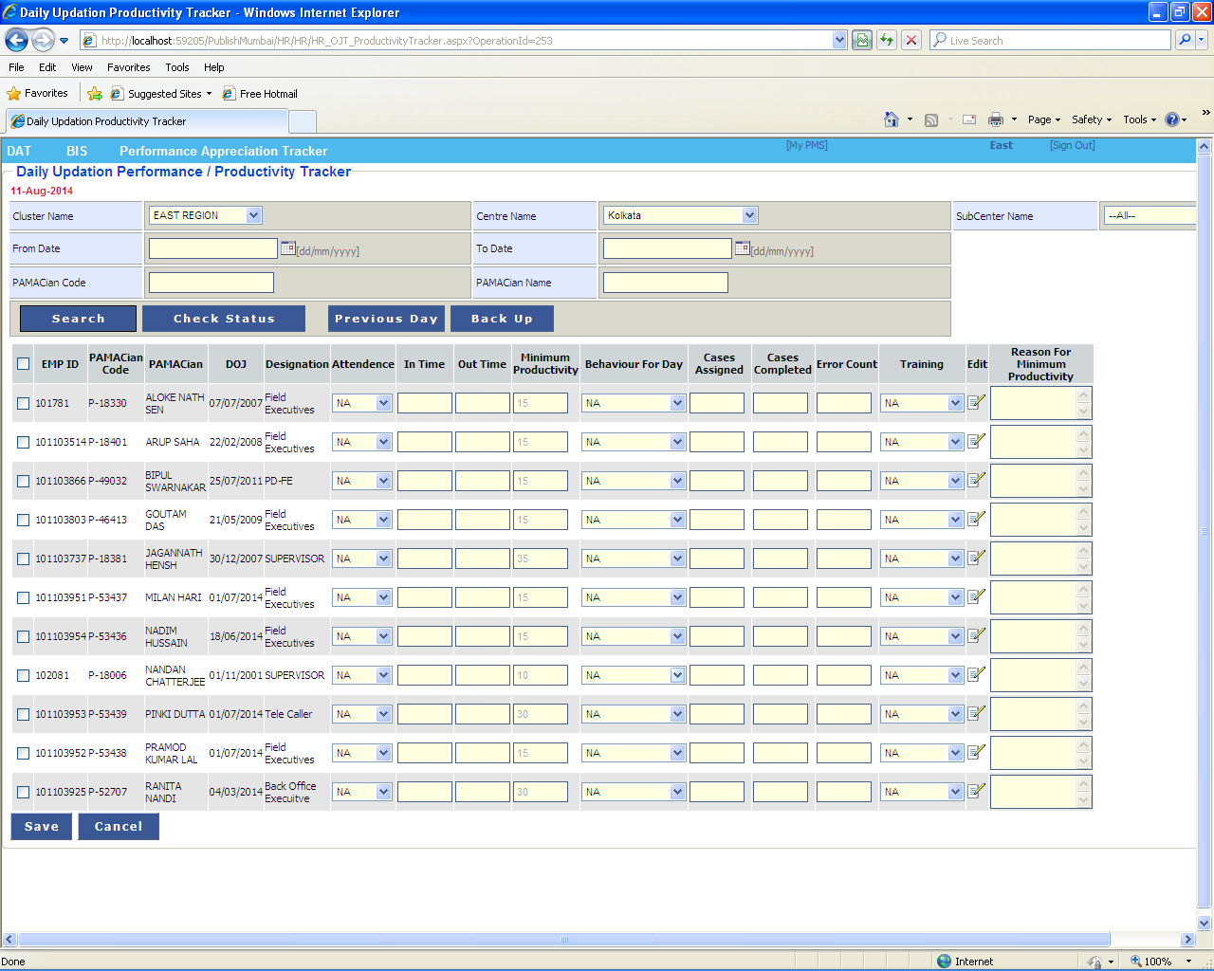
4) Click on “Back Up” button to update OJT records in absence of particular “Updating Authority” mapped against “Back-Up” by,
- Selecting Cluster Name.
- Selecting Centre Name.
- Selecting Sub centre Name.
- Between Date range (From Date & To Date).
- Entering PAMACian Code.
- Entering PAMACian Name.

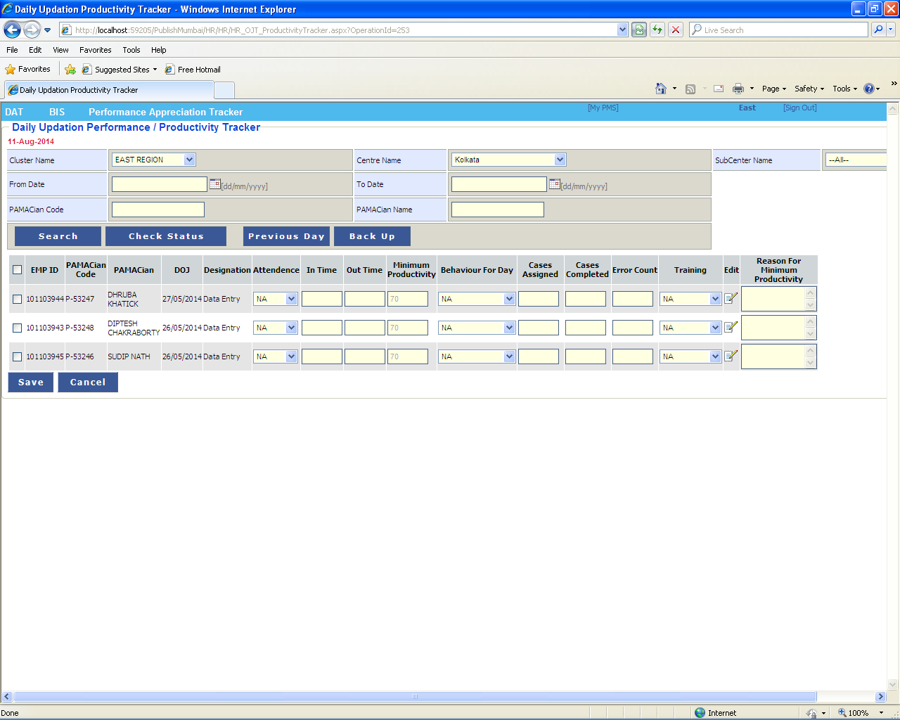
5) Follow the same process (Point # 3) to add OJT records by clicking “Previous Day” button to update OJT records.

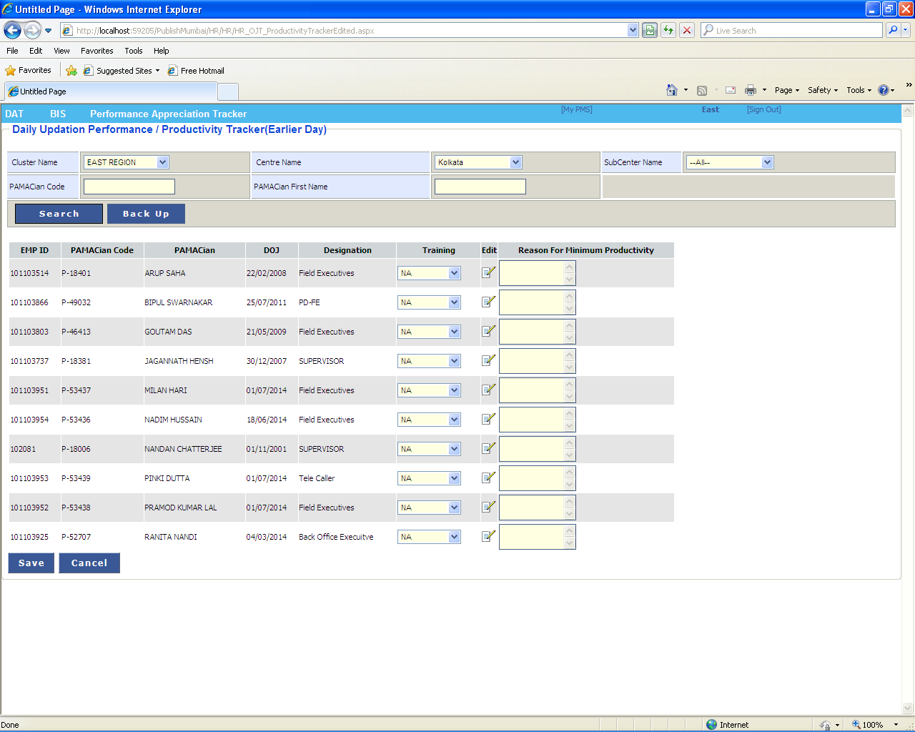
6) Follow the same process (Point #4) to add OJT records by clicking “Previous Day” button in absence of particular Updating Authority mapped against Back-Up to update OJT records.

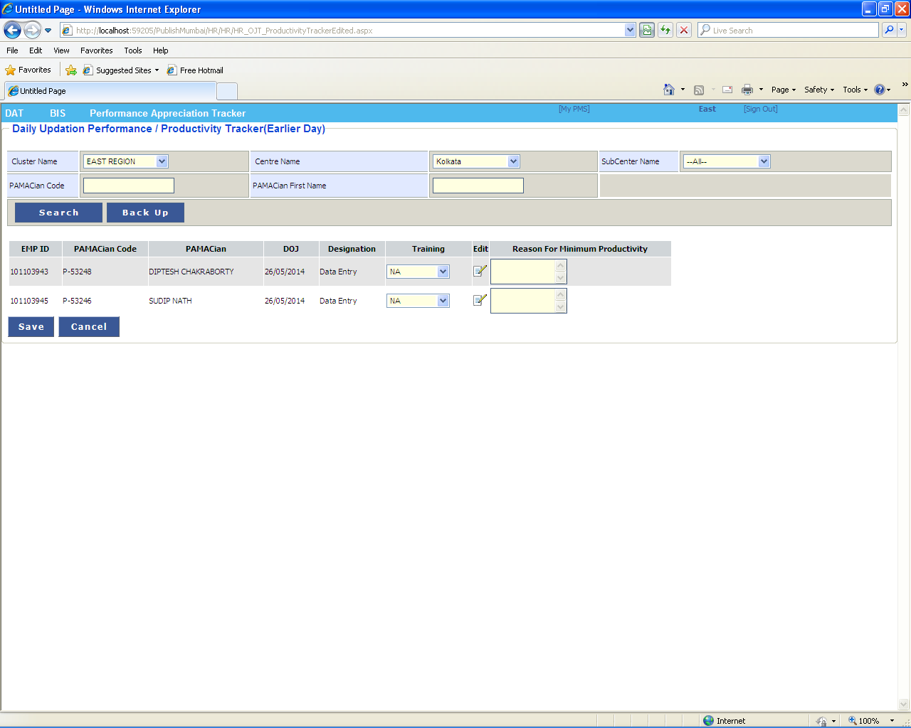
7) Print message will be visible after Adding/Updating OJT record as shown below.

